WAZER WATERJET CUTTING MACHINE

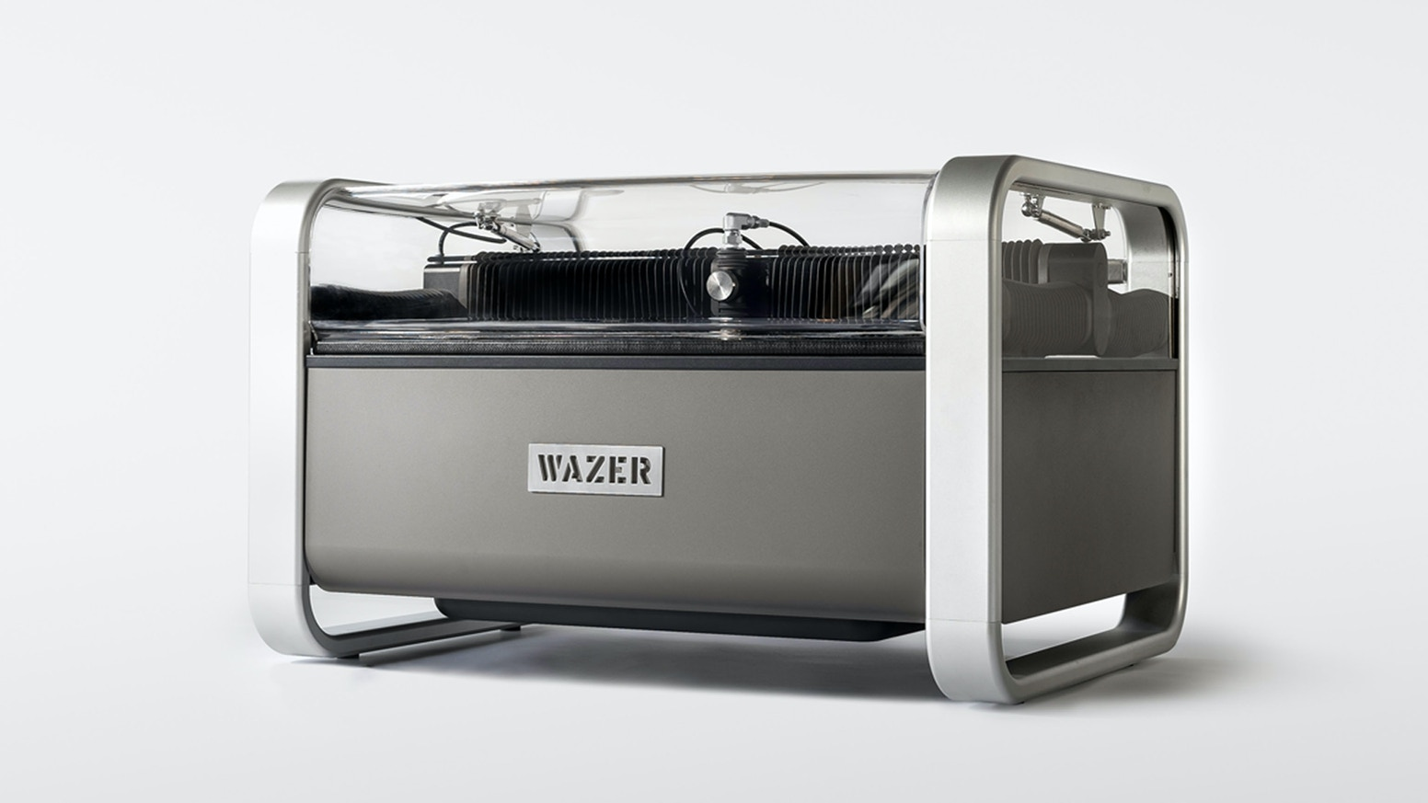

The WAZER Waterjet Cutting Machine is the first desktop waterjet designed by a group of UPenn graduates for hobbyists, artisans and small businesses. It is the first desktop version that uses high-pressure water and sand-like abrasive particles to cut through any hard or soft material with digital. WAZER takes standard drawing files like .svg or .dxf and cuts out the digital profile in virtually any material, including steel, titanium, aluminum, glass, stone, tile and carbon fiber.
WAZER has two main components:
  - The Main Unit, which contains the Cut Bed and Control Panel
  - The Pump Box, which pressurizes water and provides the energy for cutting.
HOW IT WORKS:
High-pressure waterjet technology combined with several electro-mechanical systems brings an all-in-one cutting solution.
Water is pressurized by the pump box and is then routed to the Main Unit and expelled through a small nozzle at a very high velocity. The abrasive is introduced at this point to create a slurry of water and abrasive, and this high-pressure stream of abrasive slurry performs the cutting in a waterjet system. By controlling where this stream is ejected, you are able to cut your design with digital precision.
A tank below the cut bed catches the slurry after it does its cutting work, which is then separated back into water and used abrasive by the WAZER collection system. WAZER expels the water, while the used abrasive is collected separately inside of the machine for later removal.
WAZER’s on-board Control Box is connected to all the input and output components of WAZER, which allows the machine to operate all the individual systems in harmony. Additionally, it allows the user to interact with WAZER through an on board Control Panel.
The nature of the water jet stream allows for very accurate cutting in thinner materials and the kerf shape is still acceptable for most users up to ½” thickness. Beyond that the WAZER may still be capable of cutting the material but it is important to remember that cut accuracy will diminish as the material thickness is increased (even at “fine” cut qualities). Given the fact water is involved, absorbent material such as wood, paper or dry wall are not recommended to be cut in WAZER. Moreover, attempts to engrave or surface etching material with WAZER will result in damage of machine, this is strictly prohibited.
WAZER Systems Dissection
WAZER can be broken into seven systems based on the primary functions they serve:
1. High-Pressure – This system pressurizes water for cutting, mixes the water and abrasive, and ejects the mixture toward the material.
2. Abrasive System – This system stores the abrasive and controls its flow to the high velocity Jet.
3. Enclosure – This contains the water, used abrasive, and material you are cutting within WAZER.
4. Filtration – This system separates tank water and used abrasive, collects the used abrasive from the tank and drains water out of WAZER.
5. Gantry – This system controls the motion of the Nozzle.
6. Control Box – This includes the electrical components that control and distribute signals throughout WAZER.
7. Cut Bed – This is where you fasten your material.
Wam is the software that turns your design into a cut file for WAZER; it manages important aspects of the cut, like the cut rate and when to engage or disengage cuts. Wam is browser-based and can be accessed at wam.wazer.com. Despite Wam being browser-based, all of the design file processing is done locally on your computer. As some additional insight on the matter, WAZER uses browser-based system for the following three reasons:
• Provide you free of charge updates to the software seamlessly upon login.
• Free you of software installation needs and PC/Mac compatibility issues.
• Collect information on the parameters that were chosen for a cut file so meaningful updates on features and options that are actually being used can continue to be provided.

