Registration
Guide for
2023/2024
Ellendale

www.srctc.k12.nd.us
Table of Contents
GENERAL INFORMATION.…………………..…………………………………………………………………1
AGRICULTURE EDUCATION…..……………………………………….....….………………….……….2-3
AUTOMOTIVE TECHNOLOGY...............................................................................4-5
CULINARY ARTS…………………………………………………………………………………………………6-7
EMT/AEMT/PCT………………………………………………………………………………………………8-10
ENTREPRENEURSHIP……………………………………………………………………………………………11
MARKETING………………………………………………………………………………………………………..12
SCHOOL-BASED ENTERPRISE.……………….…......................................…………………….13
SPORTS MARKETING…………………………………………………………………………………………..14
WORK-BASED LEARNING EXPERIENCE..............................................................15-16
ON-LINE COMPANION CLASSES.............................................................................17
GREAT SOUTHEAST DUAL CREDIT (Online from SRCTC)…………………………………………….18

SRCTC Students

The Southeast Region Career and Technology Center offers educational programs and support services to students from the member school districts of Campbell-Tintah, Edgeley, Ellendale, Fairmount, Hankinson, Lidgerwood, Lisbon, North Sargent, Oakes, Richland 44, Sargent Central, Wahpeton and Wyndmere School Districts. In addition, students from Kulm are afforded CTE opportunities through cooperative arrangements with the Center. This cooperation allows you to enroll in classes and enjoy educational opportunities that would not be possible by your school alone.

Career and Technical Education classes can provide you with job entry skills, the background you need to succeed in a wide variety of related occupations, and the knowledge to go on for more education and training at a junior college, college, university, or technical college.

Southeast Region Career and Technology classes are held at SRCTC-Oakes, the North Dakota State College of Science Campus, Edgeley, Lidgerwood, Lisbon, North Sargent, Richland 44, Wyndmere, Wahpeton High School and the Center Office at 2101 N. 9th St. in Wahpeton, and over the Greater Southeast Interactive TV System.

CLUBS AND ORGANIZATIONS

The many opportunities available to you as an active member of a youth organization are countless. These include local activities, a chance at becoming a state officer and attendance at state, regional, and national conventions and conferences.
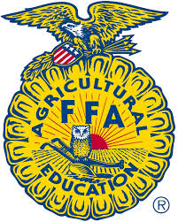
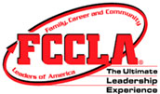

Agriculture Education
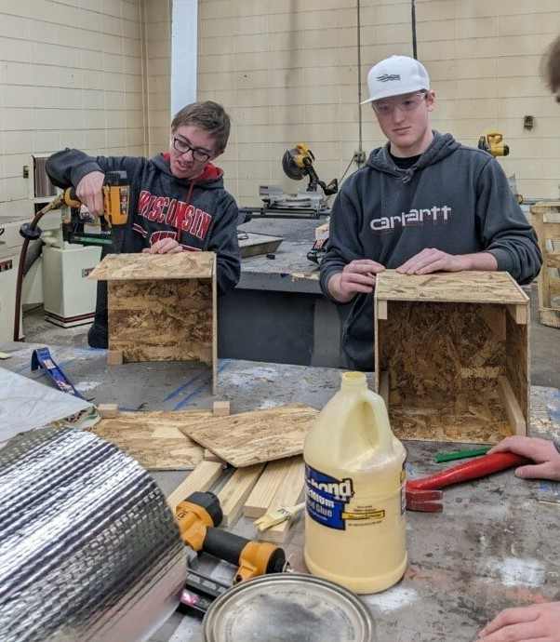

COURSE TITLE: AGRICULTURAL EDUCATION I
Grades 9-12; 1 credit; 36 weeks

Agriculture Education is a comprehensive career/technical program designed to give students competencies in the areas of plant science, animal science including pets, soil science, personal finance, public relations, introductory mechanics, woodworking, natural resource conservation, human relations and leadership development.

COURSE DESCRIPTION: Lecture demonstration, lab type courses that actively involve students in the learning process of a variety of areas of agriculture. The course is designed to give students a basic introduction to the entire agricultural/agribusiness area. Knowledge and skills developed in this course are useful for all students later in life; whatever future plans and career they choose. The development of foundation leadership skills is an important part of this course.

COURSE TITLE: AGRICULTURAL EDUCATION II
Grades 10-12; 1 credit; 36 weeks

COURSE DESCRIPTION: This course is designed to provide students with the foundation of principles and skills used in agriculture/agribusiness. It includes the use of a wide variety of tools and equipment in the lab. The course also incorporates science in applied settings using soils, plants and animals. This course offers a challenge to all students with its mechanical, science, metalworking, business and mathematical content.

COURSE TITLE: AGRICULTURAL MECHANICS I & II
Grades 11-12; 1 credit; 36 weeks

COURSE DESCRIPTION: This applied course is designed to enhance student’s perception of agriculture, its applications, and leadership development as the core foundation of the Agriculture Education program. Individual units will familiarize the student with: basic mechanical theory and skills. Areas of emphasis include leadership skills, plant science, animal science, mechanical skills, and agricultural economics.

COURSE TITLE: AGRISCIENCE I & II
Grades 11-12; 1 credit; 36 weeks

COURSE DESCRIPTION: This applied course is designed to enhance student’s perception of agriculture, its applications, and leadership development as the core foundation of the Agriculture Education program. Individual units will familiarize the student with: Plant Science, food science, animal science, agricultural research, and scientific experimentation. Students will develop experiments, conduct research, and formalize lab reports. A full understanding of biology is very important. This course is available as a CTE credit or a Science credit.

Automotive Technology

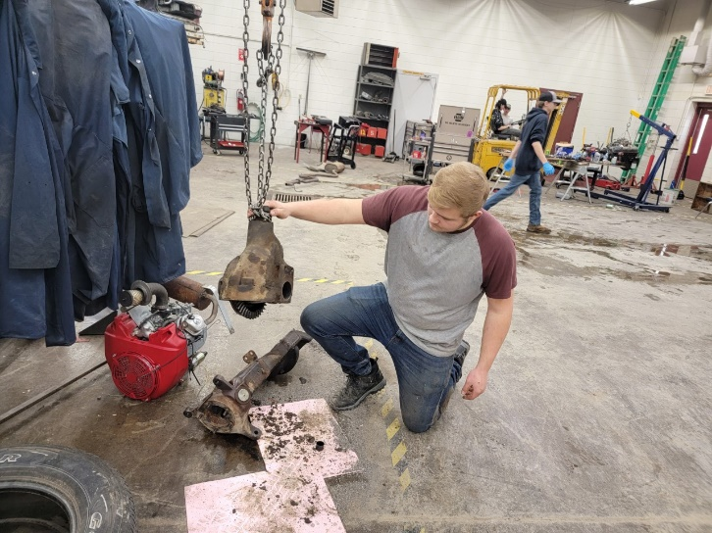

COURSE TITLE: AUTOMOTIVE TECHNOLOGY
CURRICULUM: Maintenance and Light Repair
Grades 10-12; 2 credits; 36 weeks

COURSE DESCRIPTION: Automotive Technology is an entry level automotive program taught over a two-year period, designed to give students an understanding of the operation and maintenance of the modern automobile. Program emphasis is in the major areas of brakes, manual and auto drive train, steering and suspension, engine repair, engine performance, heating and air conditioning, electrical and safety.

INSTRUCTIONAL OBJECTIVES AND/OR GOALS: Upon completion of the course, students will have a basic understanding of the modern day automobile. Students will be able to demonstrate proper human relations and communications skills in a working environment as well as develop basic skills in job seeking and career development.

CAREER TECH STUDENT ORGANIZATION: SkillsUSA is the student organization for the automotive program. Students have the opportunity to take part in their local chapter and compete in leadership and skills contests.

COURSE TITLE: AUTOMOTIVE ESSENTIALS
CURRICULUM: Auto Upkeep: Maintenance Light Repair, Auto Ownership and How Cars Work
Grades 9-12; 1 credit; 36 weeks

COURSE DESCRIPTION: Automotive Essentials is an introductory course for any student that drives an automobile. Most automotive courses are taught in a way that is geared towards students exploring the idea of a career in the automotive industry. Automotive Essentials will provide the student the fundamental knowledge and experience in owning and maintaining their own vehicles.

INSTRUCTIONAL OBJECTIVES AND/OR GOALS: This course focuses on what every car owner should know and be able to do, while also introducing them to the rapidly advancing field of automotive technology. The student will be introduced to how cars work, buying an automobile, automotive expenses, repair facilities, safety around the automobile, tools and equipment, auto care and cleaning, fluid level check, electrical system, lubrication system, fuel system, cooling system and climate control, ignition systems, suspension, steering and tires, braking system, drivetrain, exhaust and emission system and alternative fuels and designs, automotive accessories and common problems and roadside emergencies. The class discussion, videos and lab activities will provide the student with the basic knowledge and experience they need to responsibly own and take care of a car.

CAREER TECH STUDENT ORGANIZATION: SkillsUSA is the student organization for the automotive program. Students have the opportunity to take part in their local chapter and compete in leadership and skills contests.

CULINARY ARTS

COURSE TITLE: CULINARY ARTS I
Grades 10-12, 1 credits; 36 weeks

COURSE DESCRIPTION: This course of study is designed to provide students with skills in the food service and hospitality industries. This includes food preparation, service techniques, restaurant management and operation of food service businesses. Students will learn a variety of chef functions including menu planning, cooking, portion control, human relations, catering, baking, and employee supervision. Students will work in lab settings that focus on the actual preparation and serving of professionally prepared meals.

INSTRUCTIONAL OBJECTIVES AND/OR GOALS: Upon completion of the Restaurant Management and Chef Training program students will be prepared for careers in the food service industry as cooks, bakers, mid-level restaurant managers, catering employees, or a variety of positions in institutional food service settings such as schools, hospitals, and colleges.

COURSE TITLE: CULINARY ARTS II
Grades 11-12, 1 credits; 36 weeks
Prerequisite: Restaurant Management/ Chef Training I

COURSE DESCRIPTION: Restaurant Management/Chef Training II continues training for the occupation of food service and additionally includes topics on financial management, current issues in food service, legislation affecting the industry and its workers and career maturity skills. The Restaurant Management/Chef Training program prepares students for college programs in food service.

COURSE TITLE: BAKING AND PASTRY SCIENCE
Grades 10-12, 1 credits; 36 weeks
Prerequisite: None

COURSE DESCRIPTION: Baking and Pastry. That’s it! Learn how baking works and the fundamentals of baking through hands-on, real life projects. This course covers a wide array of topics from understanding ingredients such as flours, sugars, fats, eggs, milk and cocoa, along with principles such as leavening, thickening and gelling. Units may include breads (quick, artisan, yeast and laminated), cookies and brownies, pies and tarts, pastry and deserts, cakes and icings, ice creams, and specialty products such as chocolate and sugar work. This course will be tailored to higher level baking and confectionary skills and student interests.

Emergency Medical Technician (EMT)

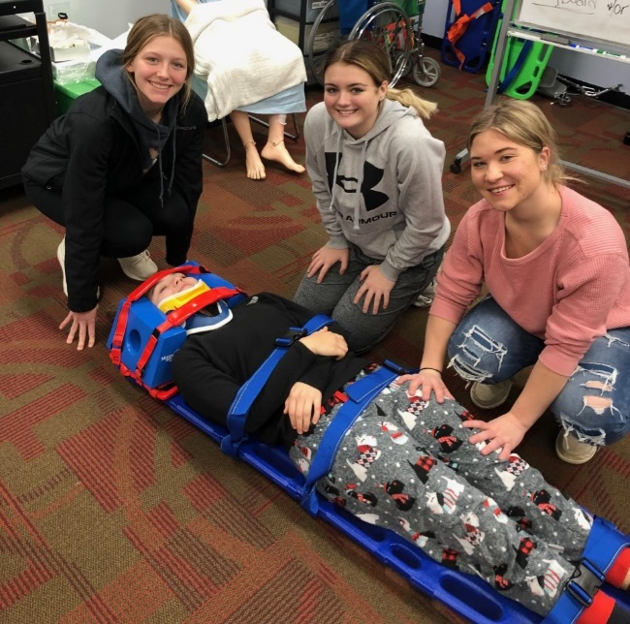

COURSE TITLE: EMERGENCY MEDICAL TECHNICIAN (EMT)
Grades 10-12; 1 credit; 36 weeks

COURSE DESCRIPTION: The Emergency Medical Technician course follows the current National Standard Curriculum, which is core curriculum of minimum required information to be presented within a 112-hour training course. It is recognized that there are additional specific educational requirements the EMT will need to operate in the field; i.e., Emergency Driver Training, Forcible Entry, Heavy Rescue, Special Needs, and so on. The EMT serves as a vital link in the health care chain of survival. This course will include all skills and classroom information necessary to provide emergency care at the basic life support level. The EMT may be utilized in a Basic Life Support ambulance service, or other specialized rescue agency. The EMT course is a fast-paced interactive learning environment, where students will gain insight in implementing life-long skills necessary to sustain, stabilize and care for ill and injured individuals.

INSTRUCTIONAL OBJECTIVES AND/OR GOALS: Upon completion of this course, students will be able to perform tasks related to:
- Preparation of the EMT/EMS operations and standards of practice
- Gain knowledge of the 4 levels of EMS certified personnel and identify scope of practice.
- Airway stabilization/management
- Patient Assessment (medical and trauma)/Documentation
- Medical/Behavioral Emergencies and OB-GYN
- Trauma;
- Care and Assessment of Infants and Children
- Ambulance Operations
- Interventions (medications and Automatic External Defibrillator). Upon successful completion of the EMT course of instruction, the student will be eligible to take the State certification exam and potentially apply for State or National Licensure.

Advanced EMT/Patient Care Technician (PCT)

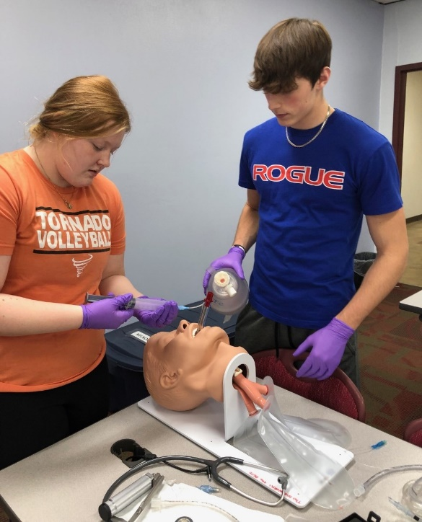

COURSE TITLE: ADVANCED EMT/PATIENT CARE TECHNICIAN (PCT)
Grades 11-12; 1 credit; 36 weeks
Prerequisite: Emergency Medical Technician (EMT)
COURSE DESCRIPTION: This course is divided over 2 semesters. The first emphasizes Advanced EMT content, followed by Patient Care course curriculum. The Advanced Emergency Medical Technician portion reinforces basic skills learned in the Emergency Medical class and introduces the student to advanced skills, focused on the acute management and transportation of critical and emergent patients. This includes training of advanced cardiac life support and advanced trauma skills. This may occur at an emergency scene until transportation resources arrive, from an emergency scene to a health care facility or between health care settings. The Patient Care Technician portion will allow the student to gain a broad view of directly assisting patients, physicians, nurses and other health care professionals in a variety of healthcare environments. Students will gain knowledge and become multi-skilled in the following areas: 12-Lead Electrocardiogram monitoring, Venipuncture (phlebotomy procedures) laboratory diagnostics, point of care testing such as blood glucose, cholesterol and hemoglobin testing. Provide direct patient care, such as obtaining vital signs, catheter, ostomy and feeding tube care, sterile dressing changes, infection control, bathing and bed making techniques.

INSTRUCTIONAL OBJECTIVES AND/OR GOALS: Upon completion of this course, students will be able to perform tasks related to the use and placement of Advanced Airway, peripheral IV access, and saline locks including administration of Normal saline and Lactated Ringers’ solution. Students will learn and demonstrate the “Six rights” of medication administration along with identifying various medications an AEMT is authorized to administer, such as sublingual nitroglycerin, glucagon, aspirin, meter dosed inhalers, Narcan and epinephrine. Students will understand and interpret electrocardiogram rhythms, including the use and implementation of various mechanical equipment such as glucose and oxygen saturation monitors. Students will have the opportunity to obtain certification in ECG, Phlebotomy, Nurse Assistant and Patient Care Technician from the National Health Careers Association and Nurse Assistant, via Head Master. This is an excellent opportunity for the student to obtain a firm knowledge base within a broad spectrum of the health care profession.

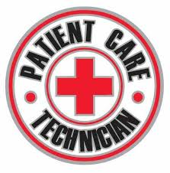
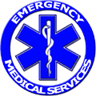

Entrepreneurship

COURSE TITLE: ENTREPRENEURSHIP
Gr. 10-12; 1 credit; 36 weeks

COURSE DESCRIPTION: Entrepreneurship is a course designed to provide an introduction to the process of turning an idea into a successful start-up business. A primary focus is for the student to explore the potential of being a successful entrepreneur. The course introduces the student to the processes for creating a successful business plan. The student will use entrepreneurial discovery processes, assess opportunities for venture creation, and develop communication skills to convince others of the potential success to implement the business entity. This course also includes units on personal finance and webpage design. The student will explore topics that include creating and designing appealing and technically-sound websites for businesses as well as successful long-term saving and investing strategies. Projects in this course will include creating, developing, and presenting a hypothetical business plan, designing a website, and composing a theoretical investment portfolio. Students in this course will have the opportunity to showcase and improve on their skills at DECA contests and conferences throughout the year.

Marketing

COURSE TITLE: MARKETING EDUCATION I
Grades 10-12; 1 Credit; 36 weeks

COURSE DESCRIPTION: To provide students with an overview of marketing occupations. It covers human relations, personality in business, business math and communications, cash register operation, change making, employee cooperation, personal grooming, career opportunities, product knowledge, consumer buying motives, and personal selling. Marketing functions include Distribution and Selling and Foundations of Economics.

INSTRUCTIONAL OBJECTIVES AND/OR GOALS: Upon completion of Marketing I, students will be able to demonstrate knowledge in distribution practices, pricing, selling, promotions and communications within the marketing world. They will also be able to demonstrate their knowledge in applying these concepts in situations where they will have to use critical thinking skills to help problem solve. Students will also complete a year in the DECA organization where they will learn leadership skills, public speaking skills and team building skills.

School-Based Enterprise
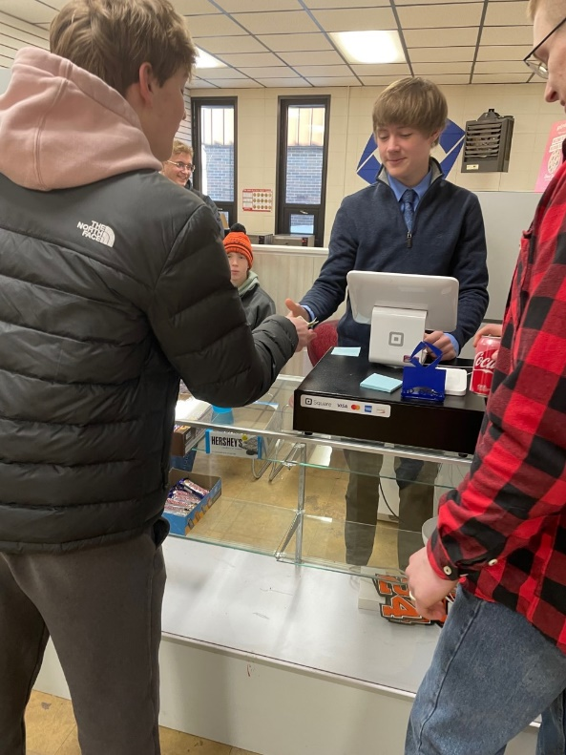
COURSE TITLE: SCHOOL-BASED ENTERPRISE
Grades 10-12; 1 credit; 36 weeks

COURSE DESCRIPTION: School-Based Enterprise (SBE) is an entrepreneurial operation in a school setting that provides goods/services to meet the needs of the market. The school-based enterprise class is managed and operated by students as hands-on learning laboratories that integrate National Curriculum Standards in Marketing, Finance, Hospitality or Management. SBEs provide realistic and practical learning experiences that reinforce classroom instruction.

School-Based Enterprise will sell to consumers through a permanent location at the Oakes SRCTC and through internet marketing. Products will include school spirit wear, food and beverage items, school supplies, signs and banners and more, as well as providing services such as creative design, advertising sales and more.

Sports & Entertainment Marketing

COURSE TITLE: SPORTS & ENTERTAINMENT MARKETING
Grades 10-12; 1 credit; 36 weeks

COURSE DESCRIPTION: Sports & Entertainment Marketing is a business course designed to use today’s broad based athletic, sports and entertainment dynamic as a foundation for students to learn communications skills in concert with advertising, sales, marketing, and media development. Students will learn how to develop marketing strategies with a focus on advertising media targeted at the world of college and professional athletics and major entertainment venues. The final project for the class will consist of student developed multi-media presentations for the marketing of a professional athletic team or major entertainment attraction. Internet marketing activities will include learning how to utilize Google research and marketing tools and how to market and sell items with on-line auction tools including actual set-up and live sales on E-Bay.

Work-Based Learning Experience

ELECTIVE: Open to all students currently enrolled or who have been
enrolled in a career, technical, business, or agriculture education
program.
CREDIT: 1 Upon completion of 180 clock hours of approved on-the-job training. Students may receive ½ credit for 90 hours of OJT.
PREREQUISITES: Past or present enrollment in a Career/Tech. class

(Work-Based Learning Experiences cannot be used to meet one of the five class requirements!)
The Work-Based Learning Experience Program is designed to provide students with on-the-job training and practical experience in addition to a comprehensive high school education. Students work at jobs relating to their individual career interests and are supervised by their employer and coordinator/instructors that also complete evaluations on each student’s work performance. Students are paid so they can earn and learn at the same time. Students should average about 5 hours per week; 180 hours during the school year for one credit.

Variations of the work experience program are available to students involved with special services and are coordinated by the Center staff. A Work Experience Program may be approved for students who have not taken a Career/Tech. class as approved by the Center Director and Home School Principal.

The following guidelines are provided to give students interested in or involved in the Work-Based Learning Experience Program a list of expectations and requirements for successful involvement and completion of the program.

1) All students must be in attendance and registered on a full-time basis. For seniors, one registered period per day may be for a qualified work-based learning experience component. Release from school will be granted for one period per day as part of that experience.
2) For 9th and 10th grade students, no release from school is permitted for work-based learning experience. Juniors may be released from school only by special exception. This exception must have approval from the home school principal and CTE Director.
3) Students must register for the Work-Based Learning Experience Program just as they register for any other class with appropriate approval from parents and their high school principal.
4) Students are not to count on their credit from the Work Based Learning Experience Program in meeting their high school graduation requirements. Loss of employment or a change in job availability will not be allowed to prevent a student from graduating from high school.
5) Students enrolled in the Work-Based Learning Experience Program are expected to maintain passing grades in school, maintain regular attendance and not allow their out-of-school work to conflict with their educational program.
6) Students who enroll in the Work-Based Learning Experience Program do not have to use school time to take part in the program, but may include after-school or weekend hours in order to balance the time requirements of school, studies, extra-curricular involvement, and still enjoy a cooperative work experience job.
7) One unit of credit will be granted for the successful completion of all requirements of the Work-Based Learning Experience Program. A limit of one credit is placed upon a student for a work experience that takes place at one job station. These requirements include:
a. Students are receiving or have received instruction in a career, technical, business, or agriculture education program.
b. 180 hours of work experience = 1 Credit. This is an average of 5 hours per week.
c. The workstation/job site conforms to state and federal wage and hour laws and regulations.
d. Students maintain the required wage and hour documentation.

Fulfilling the requirements set forth by the supervising teacher-coordinator.

On-Line Companion Classes

All work for these on-line classes are on the students’ own time or as scheduled during a free period or during study hall. Students are responsible to provide their own computer access and have a current and valid k12.nd.us e-mail account.

COURSE TITLE: CONCEPTS OF FITNESS AND WELLNESS

Grades 11-12; 1cr.; 36 wks.

Prerequisites: Medical and Health Sciences concurrent or previous enrollment

COURSE DESCRIPTION: A course designed for students of all ages that teaches the facts about exercise and physical fitness. This course is designed to teach the student the role of physical activity in maintaining adequate health and improved quality of life. Also, how to assess, develop and implement a completed lifetime fitness and wellness program and its components. The course is designed to incorporate these ideas through lecture and activity.

COURSE TITLE: INTRODUCTION TO VETERINARY SCIENCE

Grades 10-12; 1/2 cr.; 18 wks.
COURSE DESCRIPTION: In this course, you will be introduced to the basic concepts of veterinary medicine, primarily focusing on the different body systems of the major species of pets and domesticated agricultural animals. Each lesson will examine concepts in veterinary medicine that provide the student with a very broad understanding of today’s field of veterinary science. The final lesson is a career research project which gives students the opportunity to investigate a specific career in veterinary medicine.

COURSE TITLE: MEDICAL TERMINOLOGY
Grades 10-12; 1 Credit; 36 weeks

COURSE DESCRIPTION: In this online course, students will develop skills necessary for decoding commonly used medical terms. Students will learn the meaning of medical suffixes, prefixes, and word roots. Students will learn terminology associated with the body systems, diseases and disorders of those systems. Students will be expected to use the correct spelling and pronunciation of medical terms they have learned. Students will also learn common medical abbreviations.

Greater Southeast Dual Credit
College Credit Courses through NDSCS
ITV from High School
(Online from SRCTC)
COURSE TITLE: CONCEPTS OF FITNESS AND WELLNESS (HPER 100) DUAL CREDIT (Spring Semester) through Southeast Region Career & Technology Center Wahpeton

Grades 10-12; 2 college credits

COURSE DESCRIPTION: A course designed for students of all ages that teaches the facts about exercise and physical fitness. This course is designed to teach the student the role of physical activity in maintaining adequate health and improved quality of life. This course also teaches students how to assess, develop and implement a complete lifetime fitness and wellness program and its components. The course is designed to incorporate these ideas through lecture and activity.

Prerequisites: None
Student Cost: *approximately $178.86 ($89.43/college credit)
COURSE TITLE: MEDICAL TERMINOLOGY (BOTE 171-Dual Credit)
(Fall or Spring Semester) through Southeast Region Career & Technology Center Wahpeton
Grades 10-12; ½ high school credit/ 4 college credits

COURSE DESCRIPTION: Study of prefixes, suffixes, and root words of medical terms and their meaning, spelling, and pronunciation. Emphasis on building a working medical vocabulary based on body systems. Study of the location, functions, and terminology of the organs of the various systems of the body. This course is taken online through SRCTC Wahpeton and NDSCS.

Prerequisites/Corequisites: None

Student Cost: *approximately $357.72 ($89.43/college credit)

COURSE TITLE: PREVENTION AND CARE OF SPORTS RELATED INJURIES (HPER 207) (Fall or Spring Semester) through Southeast Region Career & Technology Center Wahpeton

Grades 10-12; ½ high school/ 3 college credits

COURSE DESCRIPTION: This course will provide students with the principles of athletic training. Students will learn prevention, recognition, treatment of athletic injuries, organization and administration of athletic training and basic taping techniques.
PREREQUISITES: None

Student Cost: *approximately $268.29 ($89.43/college credit)
*Tuition and fee amounts will vary slightly when 2023-2024 rates are finalized.

Programs and courses are offered as a partnership between the Public Schools of
Campbell/Tintah, Edgeley, Ellendale, Fairmount, Hankinson, Lidgerwood, Lisbon, North Sargent, Oakes,
Richland #44, Sargent Central, Wahpeton, Wyndmere and the
Southeast Region Career/Tech. Center

