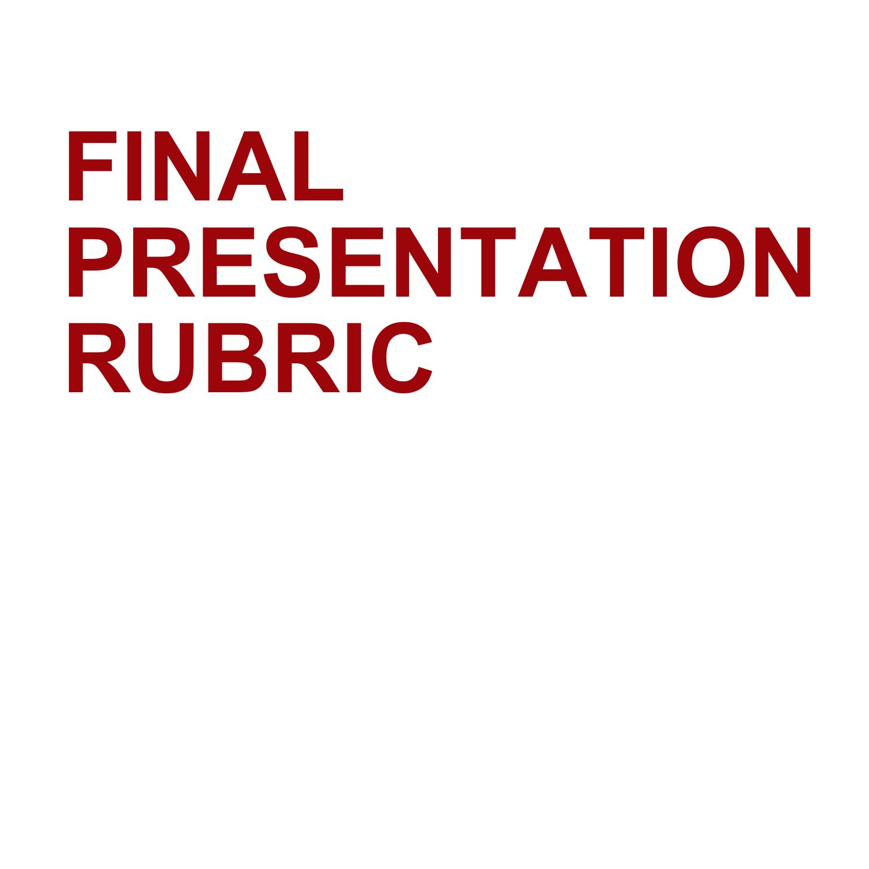

| **Category** | **Scoring Criteria** | **Points** | **Score** |
| --- | --- | --- | --- |
| Organization  (30 points) | The type of presentation is appropriate for the topic and  audience. | 15 |  |
| Information is presented in a logical sequence. | 15 |  |
| Content  (70 points) | Introduction is attention-getting, lays out the problem well, and establishes a framework for the rest of the presentation. | 10 |  |
| Technical terms are well-defined in language appropriate for the target audience. | 10 |  |
| Presentation contains accurate information. | 10 |  |
| Material included is relevant to the overall message/purpose. | 10 |  |
| Appropriate amount of material is prepared, and points made reflect well their relative importance. | 10 |  |
| There is an obvious conclusion summarizing the presentation. | 10 |  |
| Use of Multimedia | Speaker makes effective use of multimedia resources. | 10 |  |
| Presentation  (50 points) | Speaker maintains good eye contact with the audience and is appropriately animated (e.g., gestures, moving around, etc.). | 5 |  |
| Speaker uses a clear, audible voice. | 5 |  |
| Delivery is poised, controlled, and smooth. | 5 |  |
| Good language skills and pronunciation are used. | 10 |  |
| Visual aids are well prepared, informative, effective, and not distracting. | 10 |  |
| Length of presentation is within the assigned time limits. | 5 |  |
| Information was well communicated. | 10 |  |
| Score | Total Points | 150 |  |

| Remarks: | |
| --- | --- |
| Student Name |  |
| Evaluator Name | Date |