**Registration**

**Guide for**

**2025/2026**

**Lisbon**



[www.srctc.k12.nd.us](http://www.srctc.k12.nd.us)

**Agriculture Education**

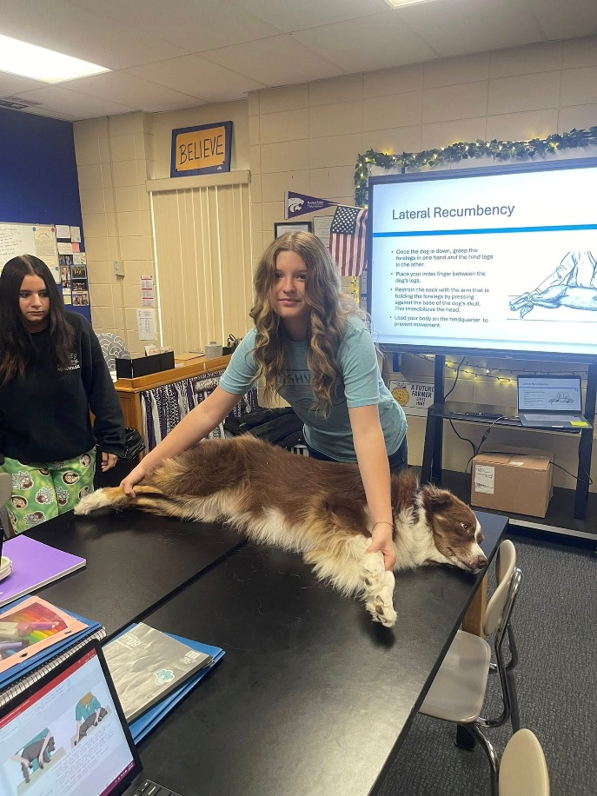

COURSE TITLE: **AGRICULTURAL BUSINESS MANAGEMENT**   
Grades 10-12; .5 credit; 18 weeks

**COURSE DESCRIPTION:** Agriculture Education is a Course designed to introduce the students to agribusiness management in the free enterprise system. It includes a study of economic principles, budgeting, recordkeeping, finance, risk management, business law, marketing, and careers in agribusiness. Leadership development and supervised agricultural experience programs are an integral part of this course.

COURSE TITLE: **AGRICULTURAL EDUCATION I**   
Grades 9-12; 1 credit; 36 weeks

Agriculture Education is a comprehensive career/technical program designed to give students competencies in the areas of plant science, animal science including pets, soil science, personal finance, public relations, introductory mechanics, woodworking, natural resource conservation, human relations and leadership development.

**COURSE DESCRIPTION:** Lecture demonstration, lab type courses that actively involve students in the learning process of a variety of areas of agriculture. The course is designed to give students a basic introduction to the entire agricultural/agribusiness area. Knowledge and skills developed in this course are useful for all students later in life; whatever future plans and career they choose. The development of foundation leadership skills is an important part of this course.

COURSE TITLE: **AGRICULTURAL EDUCATION II**   
Grades 10-12; 1 credit; 36 weeks

PREREQUISITE: Agricultural Education I

**COURSE DESCRIPTION:** This course is designed to provide students with the foundation of principles and skills used in agriculture/agribusiness. It includes the use of a wide variety of tools and equipment in the lab. The course also incorporates science in applied settings using soils, plants and animals. This course offers a challenge to all students with its mechanical, science, metalworking, business and mathematical content.

COURSE TITLE: **AGRICULTURAL MECHANICS I & II**

Grades 10-12; 1 credit; 36 weeks

**COURSE DESCRIPTION:** This applied course is designed to enhance student’s perception of agriculture, its applications, and leadership development as the core foundation of the Agriculture Education program. Individual units will familiarize the student with: basic mechanical theory and skills. Areas of emphasis include leadership skills, plant science, animal science, mechanical skills, and agricultural economics.

COURSE TITLE: **AGRISCIENCE I & II**Grades 10-12; 1 credit; 36 weeks

**COURSE DESCRIPTION:** This applied course is designed to enhance student’s perception of agriculture, its applications, and leadership development as the core foundation of the Agriculture Education program. Individual units will familiarize the student with: Plant Science, food science, animal science, agricultural research, and scientific experimentation. Students will develop experiments, conduct research, and formalize lab reports. A full understanding of biology is very important. This course is available as a CTE credit or a Science credit.

COURSE TITLE: **BOTANY/HORTICULTURAL SCIENCE I**

Grades 9-12; 1 credit; 36 weeks

**COURSE DESCRIPTION:** These courses prepare students to produce greenhouse/nursery plants and to maintain plant growth and propagation structures. Topics to be covered include: soils, plants, plant identification, and plant entomology. Courses examine the importance of plant cell structures, functions of cells, plant processes, nonvascular plants, vascular plants, roots, stems, leaves, flowers, and reproduction of plants. Students may be introduced to the biological, environmental, conservation and ecological concepts encountered in our environment. Landscape design units will prepare students to design, construct, and maintain planted areas and devices or the beautification of home grounds and other areas of human habitation and recreation. These courses will reinforce and extend students’ understanding of science by associating basic scientific principles and concepts with relevant applications in agriculture. Leadership development and supervised agricultural experience programs are also an integral part of this course.

COURSE TITLE: **COMMUNITY DEVELOPMENT**   
Grades 11-12; 18 weeks

**COURSE DESCRIPTION:**  This course provides students in agriculture an opportunity to understand the principles and fundamentals of the community development and gain an appreciation of essential community needs. Students will have the opportunity to study the community development process and select, plan, and implement a community development project or projects. Community leadership development and service learning are integral to the success of this course.

COURSE TITLE: **EXPLORING AGRICULTURE**   
Grades 7-8; 18 weeks

**COURSE DESCRIPTION:**  An introductory exploration of agriculture. Learning experiences involving agricultural activities such as experimenting, designing, constructing, evaluating and using tools, machines, materials and other processes that provide opportunities for creativity, problem solving, and leadership development.

COURSE TITLE: **FOUNDATIONS OF AGRICULTURE**   
Grades 9-12; 18 weeks

**COURSE DESCRIPTION:**  This applied course is designed to enhance student’s perception of agriculture, its applications, and leadership development as the core foundation of the Agriculture Education program. Individual units will familiarize the student with: basic mechanical theory and skills – emphasis will be placed on safety and proper use of tools and equipment; principles of evaluation and selection of beef, swine, sheep, horse, and dairy animals; soil and plant relationships that affect the production of food and fiber. Topics may include: soils, irrigation, land judging, plants, crop and weed identification, range management, horticulture, nursery, diseases, insects, and chemicals. This applied course introduces students to agricultural sciences with emphasis on technical skills, entrepreneurship, and occupational opportunities. Units may also include agricultural construction, food and fiber science, supervised agricultural experiences, and leadership development. Agricultural mechanics units are designed to further develop skills in selection, operation, and maintenance of engines, hydraulics, and agricultural machinery and tractors. Skills in operation and maintenance of equipment, determining a bill of materials, construction techniques, metal fabrication, and joining processes of metals and alloys will be included. Emphasis is on problem solving and scientific reasoning applied to real world problems integrating knowledge from the life and earth sciences. Foundations of Agriculture can be a continuation of Introduction of Agriculture or can be offered in alternating years with Introduction to Agriculture.

COURSE TITLE: **INTRODUCTION TO AGRICULTURE**   
Grades 9-12; 18 weeks

**COURSE DESCRIPTION:**  This applied course is designed to introduce students to agriculture, its applications, and leadership development as the core foundation of the Agriculture Education program. Individual units will familiarize the student with: basic mechanical theory and skills – emphasis will be placed on safety and proper use of tools and equipment; principles of evaluation and selection of beef, swine, sheep, horse, and dairy animals; soil and plant relationships that affect the production of food and fiber. Topics may include: soils, irrigation, land judging, plants, crop and weed identification, range management, horticulture, nursery, diseases, insects, and chemicals. This applied course introduces students to agricultural sciences with emphasis on technical skills, entrepreneurship, and occupational opportunities. Units may also include agricultural construction, food and fiber science, supervised agricultural experiences, and leadership development. Agricultural mechanics units are designed to develop skills in selection, operation, and maintenance of engines, hydraulics, and agricultural machinery and tractors. Skills in operation and maintenance of equipment, determining a bill of materials, construction techniques, metal fabrication, and joining processes of metals and alloys will be included. Emphasis is on problem solving and scientific reasoning applied to real world problems integrating knowledge from the life and earth sciences.

COURSE TITLE: **NATURAL/ENVIRONMENTAL RESOURCES**   
Grades 9-10; 18 weeks (2nd semester)

**COURSE DESCRIPTION:**  This course provides an opportunity for students to increase awareness of the close ties among living organisms. Natural and environmental concerns with the interrelationships of living organisms and the world around us. Leadership development and supervised agricultural experience programs are also an integral part of this course.

COURSE TITLE: **SMALL ANIMAL CARE**   
Grades 9-10; 18 weeks (1st semester)

**COURSE DESCRIPTION:**  This course is designed to teach students about the management of small animals, which may include, but are not limited to, small mammals, amphibians, reptiles, avian, dogs, and cats. The student will understand the importance of responsible small animal ownership by explaining the domestication and use of small animals, the influence small animals and the small animal industry on society, and the hazards associated with working in the small animal industry (including transmittance of disease and handling of dangerous chemicals). The student will evaluate current topics in animal rights and animal welfare, thus understanding the care and management requirements for a variety of small animals and be able to discuss the physical characteristics for each species studied; list the breeds or types of each species; discuss the habitat, housing, and equipment needs for each; compare and contrast nutritional requirements; describe and practice common methods of handling; and use available laboratory equipment to perform procedures.

**Work-Based Learning Experience**



ELECTIVE: Open to all students currently enrolled or who have been

enrolled in a career, technical, business, or agriculture education

program.

CREDIT: 1 Upon completion of 180 clock hours of approved on-the-job training. Students may receive ½ credit for 90 hours of OJT.

PREREQUISITES: Past or present enrollment in a Career/Tech. class

**(Work-Based Learning Experiences cannot be used to meet one of the five class requirements!)**

The Work-Based Learning Experience Program is designed to provide students with on-the-job training and practical experience in addition to a comprehensive high school education. Students work at jobs relating to their individual career interests and are supervised by their employer and coordinator/instructors that also complete evaluations on each student’s work performance. Students are paid so they can earn and learn at the same time. Students should average about 5 hours per week; 180 hours during the school year for one credit.

Variations of the work experience program are available to students involved with special services and are coordinated by the Center staff. A Work Experience Program may be approved for students who have not taken a Career/Tech. class as approved by the Center Director and Home School Principal.

The following guidelines are provided to give students interested in or involved in the Work-Based Learning Experience Program a list of expectations and requirements for successful involvement and completion of the program.

1) All students must be in attendance and registered on a full-time basis. For seniors, one registered period per day may be for a qualified work-based learning experience component. Release from school will be granted for one period per day as part of that experience.

2) For 9th and 10th grade students, **no release from school** is permitted for work-based learning experience. Juniors may be released from school only by special exception. This exception must have approval from the home school principal and CTE Director.

3) Students must register for the Work-Based Learning Experience Program just as they register for any other class with appropriate approval from parents and their high school principal.

4) Students are not to count on their credit from the Work Based Learning Experience Program in meeting their high school graduation requirements. Loss of employment or a change in job availability will not be allowed to prevent a student from graduating from high school.

5) Students enrolled in the Work-Based Learning Experience Program are expected to maintain passing grades in school, maintain regular attendance and not allow their out-of-school work to conflict with their educational program.

6) Students who enroll in the Work-Based Learning Experience Program do not have to use school time to take part in the program, but may include after-school or weekend hours in order to balance the time requirements of school, studies, extra-curricular involvement, and still enjoy a cooperative work experience job.

7) One unit of credit will be granted for the successful completion of all requirements of the Work-Based Learning Experience Program. A limit of one credit is placed upon a student for a work experience that takes place at one job station. These requirements include:

a. Students are receiving or have received instruction in a career, technical, business, or agriculture education program.

b. 180 hours of work experience = 1 Credit. This is an average of 5 hours per week.

c. The workstation/job site conforms to state and federal wage and hour laws and regulations.

d. Students maintain the required wage and hour documentation.

Fulfilling the requirements set forth by the supervising teacher-coordinator.