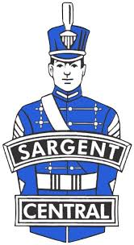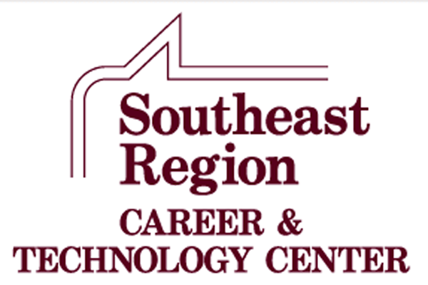

**Southeast Region**

**Career and Technology Center**

**Courses Offered   
 Sargent Central**

**2025-2026**

**IN-HOUSE COURSES**

**IN-HOUSE COURSES**

**Agricultural Education**

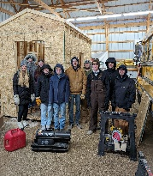**Agriculture Education** is a comprehensive career/technical program designed to give students competencies in the areas of plant science, animal science including pets, soil science, personal finance, public relations, introductory mechanics, woodworking, natural resource conservation, human relations and leadership development. Lecture demonstration and lab type courses actively involve students in the learning process of a variety of areas of agriculture.

**Automotive Technology**

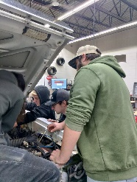**Automotive Technology** is a comprehensive vocational automotive program designed to give students an understanding of the operation and maintenance of the modern automobile. Program emphasis is in the major areas of brakes, manual and auto drive train, steering and suspension, engine repair, engine performance, heating and air conditioning, electrical and safety. **Automotive Essentials** is an introductory course for any student that drives an automobile. Most automotive courses are taught in a way that is geared towards students exploring the idea of a career in the automotive industry. This course will provide the student the fundamental knowledge and experience in owning and maintaining their own vehicle.

**Culinary Arts/Baking and Pastry Science**

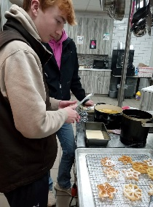**Culinary Arts** is designed to provide students with skills in the food service and hospitality industries. This includes food preparation, service techniques, restaurant management and operation of food service businesses. Students will learn a variety of chef functions including menu planning, cooking, portion control, human relations, catering, baking, and employee supervision. Students will work in lab settings that focus on the actual preparation and serving of professionally prepared meals. **Baking and Pastry Science** covers how baking works and the fundamentals of baking through hands-on, real-life projects. This course covers a wide array of topics from understanding ingredients such as flour, sugars, fats, eggs, milk and cocoa, to principles such as leavening, thickening and gelling. This course will be tailored to higher-level baking and confectionary skills and student interests.

**Emergency Medical Technician/Advanced EMT/Patient Care Technician (PCT)**

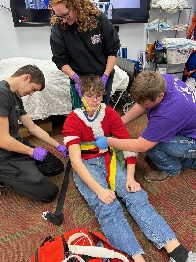The **Emergency Medical Technician** course follows the current National Standard Curriculum, which is a core curriculum of the minimum required information to be presented within a 112-hour training course. It is recognized that there are additional specific educational requirements the EMT will need to operate in the field; i.e., Emergency Driver Training, Forcible Entry, Heavy Rescue, Special Needs, and so on. The EMT serves as a vital link in the health care chain of survival. This course will include all skills and classroom information necessary to provide emergency care at the basic life support level. The EMT may be utilized in a Basic Life Support ambulance service, or other specialized rescue agency. The EMT course is a fast-paced interactive learning environment, where students will gain insight in implementing life-long skills necessary to sustain, stabilize and care for ill and injured individuals.

**Advanced Emergency Medical Technician (AEMT)/Patient Care Technician (PCT)** is divided over two semesters. The first emphasizes Advanced EMT content, followed by the Patient Care course curriculum.The **Advanced Emergency Medical Technician** portion reinforces basic skills learned in the Emergency Medical class and introduces the student to advanced skills, focused on the acute management and transportation of critical and emergent patients. This includes training in advanced cardiac life support and advanced trauma skills. This may occur at an emergency scene until transportation resources arrive, from an emergency scene to a health care facility or between health care settings. **Prerequisite: Emergency Medical Technician (EMT)**

**The Patient Care Technician** portion will allow the student to gain a broad view of directly assisting patients, physicians, nurses and other healthcare professionals in a variety of healthcare environments. Students will gain knowledge and become multi-skilled in the following areas: 12-Lead Electrocardiogram monitoring, Venipuncture (phlebotomy procedures) laboratory diagnostics, point of care testing such as blood glucose, cholesterol and hemoglobin testing. provide direct patient care, such as obtaining vital signs, catheter, ostomy and feeding tube care, sterile dressing changes, infection control, bathing and bed-making techniques. Following the course, students will have the opportunity of testing for certification as a nurse aid and/or patient care technician, if the student chooses to do so.

**Entrepreneurship**

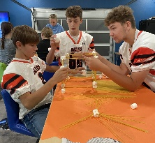**Entrepreneurship** is a course designed to provide an introduction to the process of turning an idea into a successful start-up business. A primary focus is for the student to explore the potential of being a successful entrepreneur. The course introduces the student to the processes for creating a successful business plan. The student will use entrepreneurial discovery processes, assess opportunities for venture creation, and develop communication skills to convince others of the potential success of implementing the business entity. This course also includes units on personal finance and webpage design.

**Marketing Education I**

**Marketing Education I** provides students with an overview of marketing occupations. It covers human relations, personality in business, business math and communications, cash register operation, change-making, employee cooperation, personal grooming, career opportunities, product knowledge, consumer buying motives, and personal selling. Marketing functions include Distribution and Selling and Foundations of Economics. Upon completion of Marketing I, students will be able to demonstrate knowledge of distribution practices, pricing, selling, promotions and communications within the marketing world. They will also be able to demonstrate their knowledge in applying these concepts in situations where they will have to use critical thinking skills to help problem solve. Students will also complete a year in the DECA organization where they will learn leadership skills, public speaking skills and team-building skills.

**School-Based Enterprise**

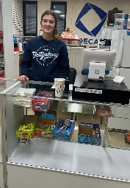**School-Based Enterprise** (SBE) is an entrepreneurial operation in a school setting that provides goods/services to meet the needs of the market. The school-based enterprise class is managed and operated by students as hands-on learning laboratories that integrate National Curriculum Standards in Marketing, Finance, Hospitality or Management. School-Based Enterprise will sell to consumers through a permanent location at the Oakes SRCTC and through internet marketing. Products will include school spirit wear, food and beverage items, school supplies, signs and banners and more, as well as providing services such as creative design, advertising sales and more.

**Sports & Entertainment Marketing**

**Sports & Entertainment Marketing** is a business course designed to use today’s broad-based athletic, sports and entertainment dynamic as a foundation for students to learn communications skills in concert with advertising, sales, marketing, and media development. Students will learn how to develop marketing strategies with a focus on advertising media targeted at the world of college and professional athletics and major entertainment venues. The final project for the class will consist of student-developed multi-media presentations for the marketing of a professional athletic team or major entertainment attraction. Internet marketing activities will include learning how to utilize Google research and marketing tools and how to market and sell items with online auction tools including actual set-up and live sales on E-Bay.

**Work-Based Learning Experience**

**(Cannot be used to meet one of the five class requirements)**

**Work-Based Learning Experience** is designed to provide students with on-the-job training and practical experience in addition to a comprehensive high school education. Students work at jobs relating to their individual career interests and are supervised by their employer and coordinator/instructors who also complete evaluations on each student’s work performance. Students are paid so they can earn and learn at the same time. Students should average about 5 hours per week; 180 hours during the school year for one credit.

Variations of the work-based experience program are available to students involved with special services and are coordinated by the Center staff. A work-based experience program may be approved for students who have not taken a Career/Tech. class as approved by the Center Director and Home School Principal.

The following guidelines are provided to give students interested in or involved in the Work-Based Experience Program a list of expectations and requirements for successful involvement and completion of the program.

1) All students must be in attendance and registered on a full-time basis. For seniors one registered period per day may be for a qualified work-based experience component. Release from school will be granted for one period per day as part of that experience.

2) For 9th and 10th grade students, **no release from school** is permitted for the work-based learning experience. Juniors may be released from school only by special exception. This exception must have approval from the home school principal, and CTE Director.

3) Students must register for the Work-Based Experience Program just as they register for any other class with appropriate approval from parents and their high school principal.

4) Students are not to count on their credit from the work-based experience program in meeting their high school graduation requirements. Loss of employment or a change in job availability will not be allowed to prevent a student from graduating from high school.

5) Students enrolled in the Work-Based Experience Program are expected to maintain passing grades in school, maintain regular attendance and not allow their out-of-school work to conflict with their educational program.

6) Students who enroll in the Work-Based Experience Program do not have to use school time to take part in the program but may include after-school or weekend hours in order to balance the time requirements of school, studies, extra-curricular involvement, and still enjoy a work-based learning experience job.

7) One unit of credit will be granted for the successful completion of all requirements of the Work-Based Experience Program. A limit of one credit is placed upon a student for a work experience that takes place at one job station. These requirements include:

a. Students are receiving or have received instruction in a career, technical, business, or agriculture education program.

b. 180 hours of work experience = 1 Credit. This is an average of 5 hours per week.

c. The work station/job site conforms to state and federal wage and hour laws and regulations.

d. Students maintain the required wage and hour documentation.

Fulfilling the requirements set forth by the supervising teacher-coordinator.

**ON-LINE COMPANION COURSES**

(Students must be currently enrolled or have previously taken one Career/Technical Education class. Classes may not be substituted for the five class requirements and are to be viewed as enhancement to the regular curriculum.)

All work for these online classes is on the students’ own time or as scheduled during a free period or study hall. Students are responsible for providing their own computer access and have a current and valid k12.nd.us e-mail account.

**Concepts of Fitness and Wellness**

Grades 10-12; 1 credit; 36 weeks

Prerequisites: Medical and Health Sciences concurrent or previous enrollment

A course designed for students of all ages that teaches the facts about exercise and physical fitness. This course is designed to teach the student the role of physical activity in maintaining adequate health and improved quality of life. Also, how to assess, develop and implement a complete lifetime fitness and wellness program and its components. The course is designed to incorporate these ideas through lectures and activities.

**Introduction to Veterinary Science**

Grades 10-12; ½ credit; 18 wks.

As you proceed through this course, you will be introduced to the basic concepts of veterinary medicine, primarily focusing on the different body systems of the major species of pets and domesticated agricultural animals. Each lesson will examine concepts in veterinary medicine that will provide you with a very broad understanding of what the field of veterinary science is today. It is not the purpose of this course to turn you into a veterinarian, but rather to help you develop an appreciation for the vast nature of the science and to help you understand what is involved in this field.

**Medical Terminology**

Grades 10-12; 1 Credit; 36 weeks

In this course, students will develop skills necessary for decoding commonly used medical terms. Students will learn the meaning of medical suffixes, prefixes, and word roots. Students will learn terminology associated with the body systems, diseases and disorders of those systems. Students will be expected to use correct spelling and pronunciation of medical terms they have learned. Students will also learn common medical abbreviations. This course is a self-paced course. (May be available for college credit)