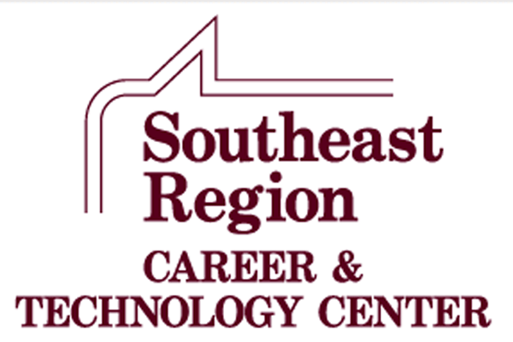

**Southeast Region**

**Career and Technology Center**

**Courses Offered   
 Ellendale**

**2025-2026**

**IN-HOUSE COURSES**

**IN-HOUSE COURSES**

**Agricultural Education**

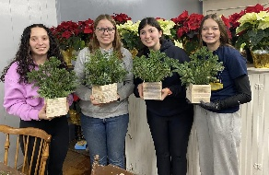**Agriculture Education** is a comprehensive career/technical program designed to give students competencies in the areas of plant science, animal science including pets, soil science, personal finance, public relations, introductory mechanics, woodworking, natural resource conservation, human relations and leadership development. Lecture demonstration and lab type courses actively involve students in the learning process of a variety of areas of agriculture.

**Automotive Technology**

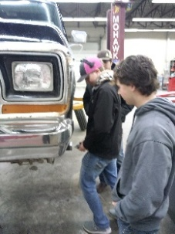**Automotive Technology** is a comprehensive vocational automotive program designed to give students an understanding of the operation and maintenance of the modern automobile. Program emphasis is in the major areas of brakes, manual and auto drive train, steering and suspension, engine repair, engine performance, heating and air conditioning, electrical and safety. **Automotive Essentials** is an introductory course for any student that drives an automobile. Most automotive courses are taught in a way that is geared towards students exploring the idea of a career in the automotive industry. This course will provide the student the fundamental knowledge and experience in owning and maintaining their own vehicle.

**Culinary Arts/Baking and Pastry Science**

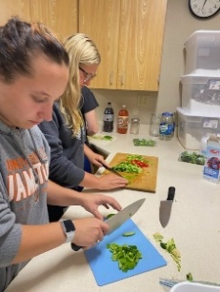**Culinary Arts** is designed to provide students with skills in the food service and hospitality industries. This includes food preparation, service techniques, restaurant management and operation of food service businesses. Students will learn a variety of chef functions including menu planning, cooking, portion control, human relations, catering, baking, and employee supervision. Students will work in lab settings that focus on the actual preparation and serving of professionally prepared meals. **Baking and Pastry Science** covers how baking works and the fundamentals of baking through hands-on, real-life projects. This course covers a wide array of topics from understanding ingredients such as flour, sugars, fats, eggs, milk and cocoa, to principles such as leavening, thickening and gelling. This course will be tailored to higher-level baking and confectionary skills and student interests.

**Emergency Medical Technician/Advance EMT/Patience Care Technician**

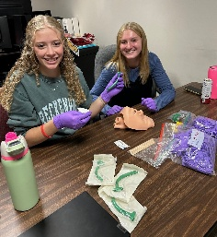The **Emergency Medical Technician** course follows the current National Standard Curriculum, which is a core curriculum of the minimum required information to be presented within a 112-hour training course. It is recognized that there are additional specific educational requirements the EMT will need to operate in the field; i.e., Emergency Driver Training, Forcible Entry, Heavy Rescue, Special Needs, and so on. The EMT serves as a vital link in the healthcare chain of survival. This course will include all skills and classroom information necessary to provide emergency care at the basic life support level. The EMT may be utilized in a Basic Life Support ambulance service, or other specialized rescue agency. The EMT course is a fast-paced interactive learning environment, where students will gain insight in implementing life-long skills necessary to sustain, stabilize and care for ill and injured individuals.

The **Advanced** **Emergency Medical Technician** portion reinforces basic skills learned in the Emergency Medical class and introduces the student to advanced skills, focused on the acute management and transportation of critical and emergent patients. This includes training in advanced cardiac life support and advanced trauma skills. This may occur at an emergency scene until transportation resources arrive, from an emergency scene to a health care facility or between health care settings. The **Patient Care Technician** portion will allow the student to gain a broad view of directly assisting patients, physicians, nurses and other healthcare professionals in a variety of healthcare environments. Students will gain knowledge and become multi-skilled in the following areas: 12-Lead Electrocardiogram monitoring, Venipuncture (phlebotomy procedures) laboratory diagnostics, and point-of-care testing such as blood glucose, cholesterol and hemoglobin testing. Provide direct patient care, such as obtaining vital signs, catheter, ostomy and feeding tube care, sterile dressing changes, infection control, bathing and bed-making techniques. Following the course, students will have the opportunity of testing for certification as a nurse aid and/or patient care technician, if the student chooses to do so.

**Entrepreneurship**

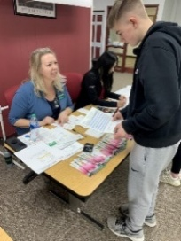**Entrepreneurship** is a course designed to provide an introduction to the process of turning an idea into a successful start-up business. A primary focus is for the student to explore the potential of being a successful entrepreneur. The course introduces the student to the processes for creating a successful business plan. The student will use entrepreneurial discovery processes, assess opportunities for venture creation, and develop communication skills to convince others of the potential success of implementing the business entity. This course also includes units on personal finance and web page design.

**School-Based Enterprise**

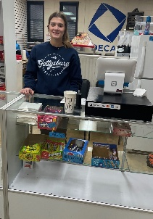**School-Based Enterprise** (SBE) is an entrepreneurial operation in a school setting that provides goods/services to meet the needs of the market. The school-based enterprise class is managed and operated by students as hands-on learning laboratories that integrate National Curriculum Standards in Marketing, Finance, Hospitality or Management. School-Based Enterprise will sell to consumers through a permanent location at the Oakes SRCTC and through internet marketing. Products will include school spirit wear, food and beverage items, school supplies, signs and banners and more, as well as providing services such as creative design, advertising sales and more.

**ON-LINE COMPANION COURSES**

All work for these online classes is on the students’ own time or as scheduled during a free period or study hall. Students are responsible for providing their own computer access and have a current and valid k12.nd.us e-mail account.

**Concepts of Fitness and Wellness**

Grades 10-12; 1 credit; 36 weeks

Prerequisites: Medical and Health Sciences concurrent or previous enrollment

A course designed for students of all ages that teaches the facts about exercise and physical fitness. This course is designed to teach the student the role of physical activity in maintaining adequate health and improved quality of life. Also, how to assess, develop and implement a complete lifetime fitness and wellness program and its components. The course is designed to incorporate these ideas through lectures and activities.

**Introduction to Veterinary Science**

Grades 10-12; ½ credit; 18 wks.

As you proceed through this course, you will be introduced to the basic concepts of veterinary medicine, primarily focusing on the different body systems of the major species of pets and domesticated agricultural animals. Each lesson will examine concepts in veterinary medicine that will provide you with a very broad understanding of what the field of veterinary science is today. It is not the purpose of this course to turn you into a veterinarian, but rather to help you develop an appreciation for the vast nature of the science and to help you understand what is involved in this field.

**Medical Terminology**

Grades 10-12; 1 Credit; 36 weeks

In this course, students will develop skills necessary for decoding commonly used medical terms. Students will learn the meaning of medical suffixes, prefixes, and word roots. Students will learn terminology associated with the body systems, diseases and disorders of those systems. Students will be expected to use correct spelling and pronunciation of medical terms they have learned. Students will also learn common medical abbreviations. This course is a self-paced course. (May be available for college credit)